Lesson | Learning Focus | Assessment | Key Words
Poetry Anthology |  |  | Inferiority  Superiority  Opulence  Industrialisation  Bourgeoisie  Proletariat  Marxism  Socialism  Capitalism  Idyllic  Tainted  Internecine  Comparative  Microcosm  Edifying  Elucidating  Enlightening  Depict  Dictatorship  Tyrant  Malevolent  Era  Social  Vast  Condescending  Vitriolic  Bludgeon  Colonialism  Patriarchal  Contextual  Sub-textual
1-2 | Romantic cluster of poems- revise all, choose one to focus on in detail MITSL | Revision
3&4 | War and conflict cluster - revise all, choose one to focus on in detail MITSL | Revision
5 | Extended Write: Compare two poems from the anthology in terms of how they use power.  [30 marks] | Extended Write
Paper 2 Language
1 | Revisit mock and question-by-question performance. Identify strengths and targets. Set personal targets to improve. | Green pen
2-3 | READING: Focus on a problem question for one lesson. Probably 3 and 4 initially with some Q2 if needed. | Analysis – teacher led/self
4-5 | WRITING: One lesson on writing theory and skills, one on a scaffolded planning and writing of a Q5. | Analysis – teacher led/self
6-7 | Extended Write: ‘cold’ paper 2 mock done in class in exam conditions. Peer marked and teacher checked. | Extended Writing
Unseen
1 | Unseen poetry skills, techniques and exam strategy | Analysis – teacher led
2-3 | Unseen poetry exam practise. Scaffolding is progressively removed to promote independence. | Analysis-teacher led/self
4 | Extended write: ‘cold’ unseen poem exam question. Done in class in exam conditions. Peer marked and teacher checked. | Extended Writing
5 | Unseen poetry comparison: ‘cold’ unseen poem exam question. Done in class in exam conditions. Peer marked and teacher checked. | Extended Writing
An Inspector calls
1-2 | Revision lesson: Plot/character/themes  Cornell notes page for each. | Revision/ meta-cognition
3-4 | Extract analysis skills. Extracts chosen from text to analyse and plan answers. | Analysis- teacher led
5 | Mind map- whole play with quotes | Revision
6 | Extended write: ‘cold’ AIC exam question. Done in class in exam conditions. Peer marked and teacher checked. | Extended Writing

R

Communications Faculty- KS4 GCSE Curriculum Intent - Year 11 Unit: Language and Literature
E
V
I
S
I
O
N

I
S

T
H
E

K
E
Y

T
O

S
U
C
C
E
S
S

R | A | G | Please RAG all the AOs above and below as you complete each bank of lessons
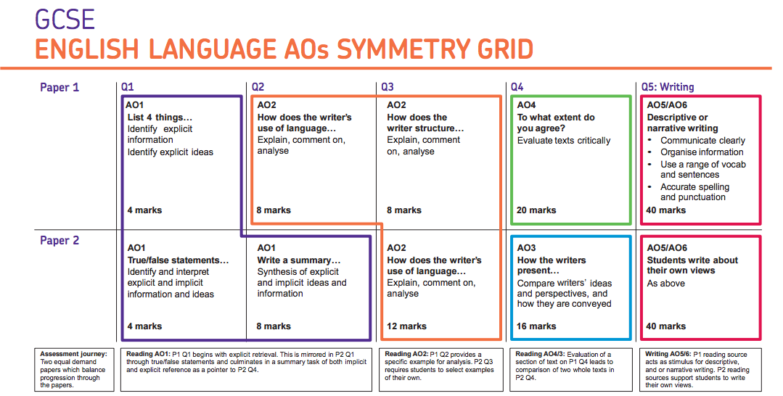

GCSE ENGLISH LITERATURE AO Grid
 |  | R | A | G
A01 | Read, understand and respond to texts.  Students should be able to:  -maintain a critical style and develop an informed personal response  -use textual references, including quotations, to support and illustrate interpretations.
A02 | Analyse the language, form and structure used by a writer to create meanings and effects, using relevant subject terminology where appropriate.
A03 | Show understanding of the relationships between texts and the contexts in which they were written.
A04 | Use a range of vocabulary and sentence structures for clarity, purpose and effect, with accurate spelling and punctuation.

