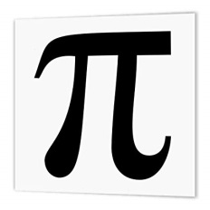
Mathematics Faculty
Year 7 Summer Term 1 – Pi Scheme
Unit 10 Overview - Coordinates and Linear Graphs

Topic | Key Ideas | Progress
 |  | R | A | G
Coordinates and Linear Graphs | I can plot coordinates in the first quadrant
 | I can plot coordinates in all four quadrants
 | I can give the coordinates of missing vertices of shapes
 | I can find the midpoint of a line segment
 | I can read and interpret information from simple linear graphs

Lesson | Learning Focus | Assessment | Key Words
1 | Plotting coordinates in the first quadrant (CM clip 84) | Formative assessment strategies e.g. MWBs, whole class questioning, Diagnostic Questions, SLOP time with self-assessment, Live Marking etc.  Assessment is also supported with our use of ILOs, which alternate between Basic Skills Checks one week and then a more individual ILO the following set through Century and Corbettmaths (see learning focus).  Finally every unit is assessed half-termly as part of our Assessment Calendar in Mathematics. | plot, coordinate, quadrant, positive, axis
2 | Plotting coordinates in all four quadrants (CM clip 84) |  | plot, coordinate, quadrant, positive, negative, axis
3 | Finding the coordinates of missing vertices of shapes (CM clip 85) |  | plot, coordinate, quadrant, positive, negative, axis, vertices, triangle, isosceles, equilateral, rectangle, parallelogram
4 | Finding the midpoint of a line segment (CM clip 87) |  | line, segment, midpoint, coordinate
5 | Reading and interpreting information from simple linear graphs |  | graph, linear, interpret, coordinate

