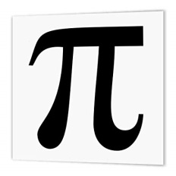
Mathematics Faculty
Year 7 Summer Term 1 - Pi Scheme
Unit 9 Overview - Special Numbers and Rounding

Topic | Key Ideas | Progress
 |  | R | A | G
Special numbers and rounding | I can round numbers to the nearest 10, 100, 1000 and integer
 | I can estimate calculations
 | I can find common multiples and factors
 | I can recognise prime numbers less than 100
 | I can calculate squares, cubes and roots
 | I can use a calculator efficiently

Lesson | Learning Focus | Assessment | Key Words
1 | Rounding numbers to the nearest 10, 100, 1000 and integer. Understanding place value with decimals (CM clips 276, 277a & 277b) | Formative assessment strategies e.g. MWBs, whole class questioning, Diagnostic Questions, SLOP time with self-assessment, Live Marking etc.  Assessment is also supported with our use of ILOs, which alternate between Basic Skills Checks one week and then a more individual ILO the following set through Century and Corbettmaths (see learning focus).  Finally every unit is assessed half-termly as part of our Assessment Calendar in Mathematics. | round, integer, decimal, place value, tenth, hundredth
2 | Estimating calculations by rounding and using inverse methods (CM clip 215) |  | estimate, approximate, round, inverse
3 | Finding common multiples and factors (CM clips 216, 218, 219 & 220) |  | multiple, factor,
4 | Recognising prime numbers (CM clip 225) |  | prime, composite, factor
5 | Calculating squares, cubes and roots (CM clips 212 – 214 & 226 - 228) |  | square, cube, root
6 | Using a calculator efficiently (CM clip 352) |  | power, index, square, cube, root, bracket, fraction, negative

