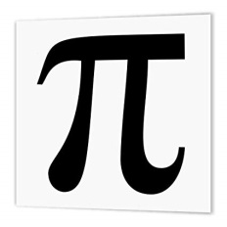
Mathematics Faculty
Year 7 Summer Term 1 – Pi Scheme
Unit 10 Overview - Coordinates and Graphs

Topic | Key Ideas | Progress
 |  | R | A | G
Coordinates and Graphs | I can plot coordinates in the first quadrant.
 | I can plot coordinates in all four quadrants.
 | I can give the coordinates of missing vertices of shapes.
 | I can read and interpret information from simple linear graphs.

Lesson | Learning Focus | Assessment | Key Words
1 | Plotting coordinates in the first quadrant (CM clip 84) | Formative assessment strategies e.g. MWBs, whole class questioning, Diagnostic Questions, SLOP time with self-assessment, Live Marking etc.  Assessment is also supported with our use of ILOs, set through Century Learning and Corbettmaths.  Finally, units are assessed through skills checks and half termly assessments, as part of our Assessment Calendar in Mathematics. | plot, coordinate, quadrant, positive, axis
2 | Plotting coordinates in all four quadrants (CM clip 84) |  | plot, coordinate, quadrant, positive, negative, axis
3 | Finding the coordinates of missing vertices of shapes (CM clip 85) |  | plot, coordinate, quadrant, positive, negative, axis, vertices, triangle, isosceles, equilateral, rectangle, parallelogram
4 | Reading and interpreting information from simple linear graphs |  | graph, linear, interpret, coordinate

