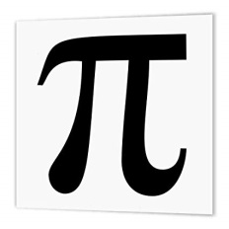
Mathematics Faculty
Year 7 Autumn Term 1 – Pi Scheme
Unit 2 Overview – Manipulating Expressions

Topic | Key Ideas | Progress
 |  | R | A | G
Manipulating Expressions | I can interpret and use algebraic notation.
 | I can simplify expressions by collecting like terms and multiplying and dividing terms.
 | I can write simple expressions from word descriptions using the 4 operations.
 | I can substitute positive integers into expressions and formulae.

Lesson | Learning Focus | Assessment | Key Words
1 | Understanding and using correct algebraic notation (CM clip 19) | Formative assessment strategies e.g. MWBs, whole class questioning, Diagnostic Questions, SLOP time with self-assessment, Live Marking etc.  Assessment is also supported with our use of ILOs, set through Century Learning and Corbettmaths.  Finally, units are assessed through skills checks and half termly assessments, as part of our Assessment Calendar in Mathematics. | notation, term, expression, variable
2 | Collecting like terms involving different lettered terms and numerical terms (CM clip 9) |  | term, like term, expression, simplify, positive, negative, add, subtract
3 | Simplifying expressions by multiplying and dividing terms (CM clips 11 & 18) |  | notation, term, expression, simplify, coefficient, power, multiply, divide
4 | Substituting positive integers into expressions (CM clip 20) |  | term, expression, substitute, positive, BIDMAS
5 | Writing simple expressions from words using the 4 operations (CM clip 16) |  | notation, term, expression
6 | Using simple formulae expressed in words (CM clip 20) |  | term, formula, substitute, positive, construct, inverse

