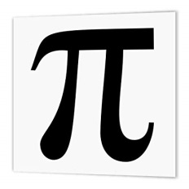
Mathematics Faculty
Year 7 Autumn Term 2 – Pi Scheme
Unit 3 Overview - Area and Volume

Topic | Key Ideas | Progress
 |  | R | A | G
Area and Volume | I can solve problems involving the area and perimeter of squares and rectangles.
 | I can calculate the area of parallelograms and triangles.
 | I can calculate the area of compound shapes.
 | I can estimate and calculate the volume of cubes and cuboids.

Lesson | Learning Focus | Assessment | Key Words
1 | Solving problems involving the area and perimeter of squares and rectangles (CM clips 45 & 241) | Formative assessment strategies e.g. MWBs, whole class questioning, Diagnostic Questions, SLOP time with self-assessment, Live Marking etc.  Assessment is also supported with our use of ILOs, set through Century Learning and Corbettmaths.  Finally, units are assessed through skills checks and half termly assessments, as part of our Assessment Calendar in Mathematics. | perimeter, dimension, rectangle, square, addition, unit, cm, length, width, cm²
2 | Calculating the area of parallelograms (CM clip 44) |  | area, parallelogram, base, vertical height, unit, cm²
3 | Calculating the area of triangles (CM clip 49) |  | area, triangle, right angle, scalene, isosceles, equilateral, base, vertical height, unit, cm²
4 | Calculating the area of compound shapes (CM clips 41 & 42) |  | area, square, rectangle, length, width, parallelogram, triangle, base, height, unit, cm²
5 | Estimating and calculating volumes of cubes and cuboids (CM clip 355) |  | estimate, volume, capacity, length, width, depth, unit, cm³

