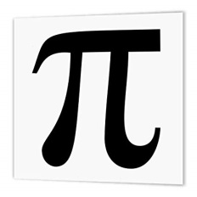
Mathematics Faculty
Year 7 Spring Term 2 – Pi Scheme
Unit 8 Overview - Ratio and Proportion

Topic | Key Ideas | Progress
 |  | R | A | G
Ratio and Proportion | I can simplify two and three-part ratios.
 | I can simplify ratios involving different units.
 | I write ratios in the form 1:n and n:1.
 | I can use the unitary method for proportion.
 | I can solve recipe problems.

Lesson | Learning Focus | Assessment | Key Words
1 | Simplifying two and three- part ratios (CM clip 269) | Formative assessment strategies e.g. MWBs, whole class questioning, Diagnostic Questions, SLOP time with self-assessment, Live Marking etc.  Assessment is also supported with our use of ILOs, set through Century Learning and Corbettmaths.  Finally, units are assessed through skills checks and half termly assessments, as part of our Assessment Calendar in Mathematics. | simplify, ratio, divide, factor, common, integer
2 | Simplifying ratios involving different units (CM clip 269) |  | ratio, convert, equal, simplify, divide, units, common, integer, factor
3 | Writing ratios in the form 1:n and n:1 (CM clip 271c) |  | ratio, form, integer, unit, simplify, divide
4 | Using the unitary method for proportion (CM clip 255a) |  | proportion, unitary, divide, multiply
5 | Solving recipe problems (CM clip 256) |  | proportion, unitary method, divide, multiply, units

