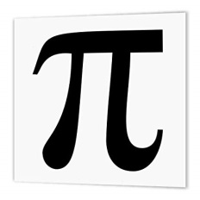
Mathematics Faculty
Year 7 Summer Term 1 - Pi Scheme
Unit 9 Overview - Special Numbers and Rounding

Topic | Key Ideas | Progress
 |  | R | A | G
Special numbers and rounding | I can round numbers to the nearest 10, 100, 1000 and integer.
 | I can estimate calculations.
 | I can find common multiples and factors.
 | I can recognise prime numbers less than 100.
 | I can calculate squares, cubes and roots.
 | I can use a calculator efficiently.

Lesson | Learning Focus | Assessment | Key Words
1 | Rounding numbers to the nearest 10, 100, 1000 and integer (CM clips 276, 277a & 277b) | Formative assessment strategies e.g. MWBs, whole class questioning, Diagnostic Questions, SLOP time with self-assessment, Live Marking etc.  Assessment is also supported with our use of ILOs, set through Century Learning and Corbettmaths.  Finally, units are assessed through skills checks and half termly assessments, as part of our Assessment Calendar in Mathematics. | round, integer, decimal, place value, tenth, hundredth
2 | Estimating calculations by rounding (CM clip 215) |  | estimate, approximate, round
3 | Finding common multiples (CM clips 218 & 220) |  | multiple, multiply
4 | Finding common factors (CM clips 216 & 219) |  | factor, divide
5 | Recognising prime numbers less than 100 (CM clip 225) |  | prime, composite, factor
6 | Calculating squares and square roots (CM clips 226 - 228) |  | square, root, multiply
7 | Calculating cubes and cube roots (CM clips 212 – 214) |  | cube, root, multiply
8 | Using a calculator efficiently, including squares, cubes, roots and brackets (CM clip 352) |  | power, index, square, cube, root, bracket

