High Tunstall College of Science Curriculum Intent
Subject: Geography Year: 11 Half term: 4

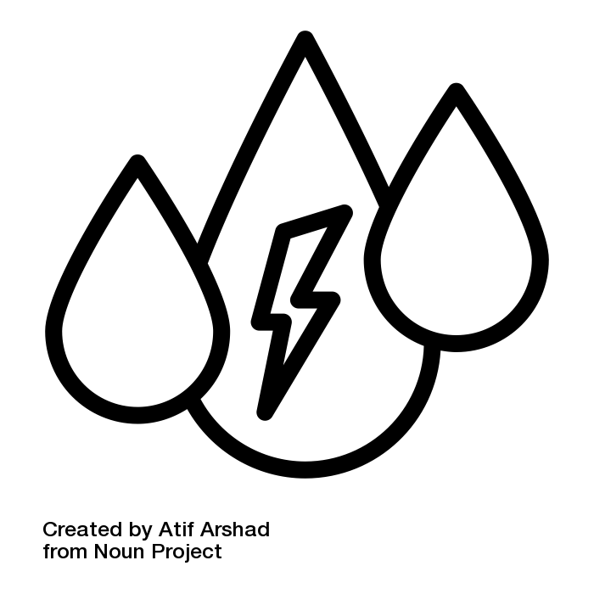
THE CHALLENGE OF
RESOURCE MANAGEMENT
Global Energy
Key ideas | Progress RAG
Demand for energy resources is rising globally but supply can be insecure, which may lead to conflict. (CGP p113-115)
Different strategies can be used to increase energy supply. (CGP p116-119)

Lesson | Learning Focus | Assessment | Key Words
1 | Areas of surplus (security) and deficit (insecurity):  • global distribution of energy consumption and supply  • reasons for increasing energy consumption: economic development, rising population, technology | Bell Task Retrieval Practice: Triple Challenge  Starter: 3T’s  Info Source: CGP p113 & GCSEPod  HTCS Challenge: Mind Map  Practice Question: Flashcard 80  Plenary: Triangle | energy security
2 | Areas of surplus (security) and deficit (insecurity):  • factors affecting energy supply: physical factors, cost of exploitation and production, technology and political factors. | Bell Task Retrieval Practice: Regular Recall  Starter: Discuss It and video clip.  Info Source: CGP p114  HTCS Challenge: iCon Remember  Practice Question: Skills Practice Flashcard 92  Plenary: Give Me Five | energy exploitation
3 | Impacts of energy insecurity – exploration of difficult and environmentally sensitive areas, economic and environmental costs, food production, industrial output, potential for conflict where demand exceeds supply. | Bell Task Retrieval Practice: Picture Prompt  Starter: Greenpeace – Shell in Antarctica  Info Source: CGP p115  HTCS Challenge: Guided Reading  Practice Question: Q1.11.51 p78 CGP workbook  Plenary: Nando’s
4 | Overview of strategies to increase energy supply:  • renewable (biomass, wind, hydro, tidal, geothermal, wave and solar) and non-renewable (fossil fuels and nuclear power) sources of energy. | Bell Task Frayer Model: Geothermal Energy  Starter: What on Earth, Where on Earth?  Info Source: CGP p116/7 & GCSEPods  HTCS Challenge: Infographic  Practice Question: Flashcard 82  Plenary: GeoScrabble | biomass, fossil fuel, geothermal energy, hydro(electric) power, nuclear power, renewable energy sources, solar energy, wind energy
5 | Overview of strategies to increase energy supply:  • an example to show how the extraction of a fossil fuel has both advantages and disadvantages: Fracking. | Bell Task Retrieval Practice: GEOG Your Memory  Starter: Frack Off! & video  Info Source: CGP p117 & GCSEPods  HTCS Challenge: Literacy Challenge - Fracking  Practice Question: Q6.1-6.4 SAM1  Plenary: Extent-O-Meter | fracking
6 | Moving towards a sustainable resource future:  • individual energy use and carbon footprints. Energy conservation: designing homes, workplaces and transport for sustainability, demand reduction, use of technology to increase efficiency in the use of fossil fuels. | Bell Task Retrieval Practice: Regular Recall  Starter: Discuss It – energy saving house.  Info Source: CGP p118/9 & GCSEPod  HTCS Challenge: Poster  Practice Question: CGP Revision Guide p120 Q22-29  Plenary: Acrostic | energy conservation, sustainable development, sustainable energy supply
7 | Moving towards a sustainable resource future:  • an example of a local renewable energy scheme in an LIC or NEE to provide sustainable supplies of energy: Rice Husks in Bihar, India | Bell Task Retrieval Practice: Picture prompt  Starter: 3T’s  Info Source: CGP p119 & video  HTCS Challenge: Q&A  Practice Question: Global Energy Revision Mat  Plenary: What is the Question?
8 | The Challenge of Resource Management end of unit assessment | AQA 80352 paper

